Production-Grade Web Platform
Architecture Reference & Component Rationale
Companion document to the step-by-step Build Guide
Revision 2 — 2026-04-23 — see final section for change log
Scope
Secure, scalable, AI-friendly SaaS platform
Target: 100+ customers/day · Headroom to 10x without rework
Five VPS tier · Zero public IPs on internal services
Social login via Google · GitHub · Microsoft · Apple

Executive Summary
This document is the architecture reference for the platform described in the companion Build Guide. It exists to answer three questions:
- What does the system look like as a whole?
- Why was each component selected over the alternatives?
- What is compatible with what, and where are the known boundaries?
The architecture is built on five VPSes across three trust zones (public, DMZ, private network). Only one VPS has a public IP address. All other services communicate over a private network, with the application server acting as the only path to the data layer. Authentication is federated through a self-hosted Authentik identity provider, which brokers social login from Google, GitHub, Microsoft, and Apple so the application only ever integrates with one identity system.
Every major component was selected against at least one alternative. Those choices are documented in the rationale section with compatibility notes, switching costs, and conditions under which a different choice would be justified.

System Architecture Diagram
The diagram below shows the full system at a glance. Three trust zones (public, DMZ, private) are color-coded. Arrows show the direction of traffic flow and its classification (user traffic, internal service calls, OIDC federation, backup data).
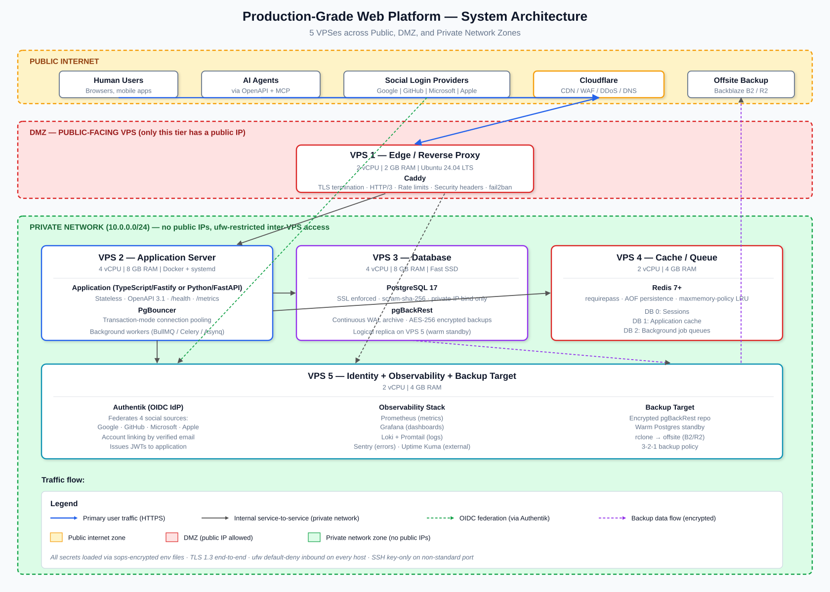
Figure 1 — Full system architecture. The Edge VPS (DMZ) is the only public-facing node. VPS 2-5 sit on a private 10.0.0.0/24 network with ufw default-deny inbound; each pair of services is allowed only on specific ports from specific peers.

Authentication Flow
The diagram below shows exactly what happens when a user clicks "Sign in with Google" (the flow is identical for GitHub, Microsoft, and Apple — only step 3's destination changes). The critical property: the application never speaks directly to upstream identity providers. Authentik brokers every provider, so the application has one integration and one token format to validate.
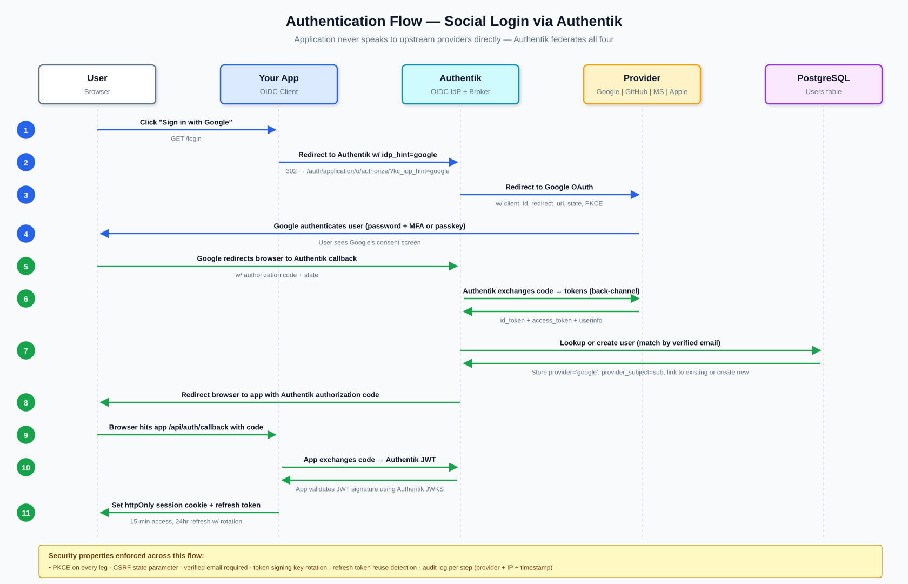
Figure 2 — Eleven-step social login flow with security properties called out. Blue arrows are forward-legs (user → provider), green arrows are return-legs (provider → app).

Component Rationale — Why Each Choice
For every layer, the table below lists the chosen component, the closest alternative, and the reason for the choice. Where multiple options are viable for different use cases, the use case conditions are given.
Layer | Chosen | Alternative | Why the chosen option
OS | Ubuntu 24.04 LTS | Debian 12 (slower-moving, same family); RHEL/Rocky (enterprise cert support) | Largest package ecosystem, 5-year LTS support window, matches tooling defaults, one hardening playbook across every VPS.
CDN / WAF | Cloudflare (free tier) | Fastly, AWS CloudFront, BunnyCDN | Free DDoS protection, global edge, managed WAF rules, DNS all in one. Competitors either cost money (Fastly, CloudFront) or lack the WAF (Bunny).
Reverse proxy | Caddy | Nginx, Traefik, HAProxy | Auto-provisions Let's Encrypt TLS with zero config; readable Caddyfile; HTTP/3 built-in. Nginx is faster at extreme scale but has more footguns and manual cert management.
Application runtime | TypeScript + Fastify (default) or Python + FastAPI | Go + Chi/Echo, Elixir + Phoenix, Ruby + Rails | Both produce automatic OpenAPI 3.1 specs (critical for AI consumption), strong typing, large ecosystems, excellent async I/O. Go is faster for CPU-heavy work; Elixir for very high concurrency; Rails for CRUD speed. Pick the one your team already knows.
Database | PostgreSQL 18 | MySQL/MariaDB, CockroachDB, MongoDB | Single engine covers relational, JSON, full-text, geospatial, time-series (TimescaleDB), and vector (pgvector) needs. MySQL is fine but weaker on JSON/extensions. Cockroach adds ops complexity. Mongo loses relational guarantees. Postgres 18 released Sept 2025; v17 still valid if you have existing tooling bound to it.
Connection pool | PgBouncer (transaction mode) | pgcat (Rust-based, sharding-aware), app-native pooling only | Battle-tested for 15+ years, extremely low overhead, standard in the Postgres world. pgcat is newer and promising for future sharding but not yet as proven.
DB backups | pgBackRest | Barman, Wal-G, pg_dump + cron | Handles full, differential, and WAL archive together with strong encryption and parallelism. Barman is equivalent; choose either. pg_dump alone is not sufficient for production.
Cache / queue | Valkey 8+ (or Redis 8+) | KeyDB, Dragonfly, Memcached, RabbitMQ | Handles sessions, cache, and job queues in one service. Valkey is a BSD-licensed Linux Foundation fork of Redis 7.2.4 (forked after Redis's 2024 license change); Redis 8 added AGPLv3 back. Both are drop-in compatible. Dragonfly is faster but younger. Memcached has no persistence or queues. RabbitMQ is overkill at this scale.
Container runtime | Docker + systemd | Podman, Kubernetes, plain binaries | Docker is the path of least resistance for CI/CD registries and deploy tooling. Kubernetes brings massive operational overhead not justified below a few thousand concurrent users. Podman is a fine drop-in if rootless is required.
Identity provider | Authentik (self-hosted) | Keycloak, Auth0, Clerk, FusionAuth | Modern Python stack, active development, clean UI, free at any scale. Keycloak is equivalent (Java, heavier). Auth0/Clerk are SaaS and get expensive fast past free tier. FusionAuth is solid but smaller community.
Auth. method | OIDC (OAuth 2.0 + ID tokens) | SAML 2.0, Magic links, LDAP | OIDC is the modern standard for web/mobile/API and is what all four social providers speak. SAML is added later for enterprise B2B customers who require it. Magic links can complement, not replace, this.
Social: Google | Sign in with Google | Apple Sign-In | Reaches 40-60% of consumer users with one click, textbook OIDC implementation, verified email skips email verification.
Social: GitHub | Sign in with GitHub | GitLab OAuth | Signals 'developer-friendly', 180M+ users in the dev audience, enables useful secondary integrations (repo import, org membership gating).
Social: Microsoft | Sign in with Microsoft (Entra ID) | Okta, Auth0 federation, direct SAML | Covers 100M+ corporate users via one button; handles both personal and work/school accounts. Standard B2B login.
Social: Apple | Sign in with Apple | Facebook/Meta Login | Strongly recommended for iOS apps offering other social logins (App Store 4.8: Sign in with Apple OR an equivalent privacy-focused alternative, relaxed Jan 2024); privacy-conscious users prefer it; one-tap Face ID/Touch ID boosts conversion.
Metrics | Prometheus + Grafana | Datadog, New Relic, InfluxDB | Industry standard, free, integrates with everything. Datadog is superior out of the box but is paid SaaS. InfluxDB is a timeseries DB without Prometheus's pull model and ecosystem.
Logs | Loki + Promtail | Elasticsearch/ELK, Graylog, Splunk | Loki is 10x cheaper to run than Elasticsearch at this scale because it indexes only labels (not content). ELK is more powerful if full-text log search is required. Splunk is enterprise-priced.
Error tracking | Sentry (self-hosted or free tier) | Rollbar, Bugsnag, Raygun | Open source, generous free tier, best Python/Node/Go integrations, release-tracking built in. Competitors are fine SaaS but add cost.
Secrets | sops + age (file-based) | HashiCorp Vault, Infisical, Doppler | Secrets stay in git, encrypted. Vault is overkill for small teams but appropriate past ~20 engineers. Infisical is a nice middle ground with a UI.
Offsite backup | Backblaze B2 or Cloudflare R2 | AWS S3, Azure Blob, GCS | B2 has free egress to Cloudflare. R2 has a generous free tier and cheap egress. S3 charges for egress.
CI/CD | GitHub Actions | GitLab CI, Forgejo Actions, Drone, Jenkins | Free for public repos and generous for private; YAML is standard; massive marketplace. Forgejo Actions if fully self-hosted is required. Jenkins is legacy.

Compatibility Matrix
What works with what, where the edges are, and which combinations require extra care. Color legend: green = compatible as-is, yellow = requires specific config, red = do not combine.
Integration | Compatibility | Notes
Caddy + Cloudflare (proxied) | Compatible | Use Cloudflare 'Full (strict)' mode; restrict origin firewall to Cloudflare IP ranges; Caddy still provisions its own Let's Encrypt cert for the origin leg.
PgBouncer (transaction mode) + Postgres prepared statements | Compatible* | *Requires PgBouncer 1.21+ for protocol-level prepared statements. Older versions break prepared statements in transaction mode — either use session pooling or upgrade.
Authentik + all four social providers simultaneously | Compatible | All four upstream providers (Google, GitHub, Microsoft, Apple) can be configured as parallel Sources on one enrollment flow. Users see all four buttons on one login page.
Account linking across providers by verified email | Compatible | All four providers return verified emails (Apple may return a private relay address but it's still verified). Authentik merges on match.
Redis + session storage + BullMQ + cache on one instance | Compatible | Use separate Redis logical databases (DB 0, 1, 2). Set maxmemory-policy to allkeys-lru on cache DB only; use noeviction on queue and session DBs to avoid data loss.
Docker --read-only + app with temp files | Compatible* | *Requires --tmpfs /tmp for anything needing temp space. Most web frameworks work; some image-processing libraries need additional tmpfs mounts.
Prometheus + node_exporter on all VPSes | Compatible | Prometheus scrapes over the private network. No changes to ufw needed beyond allowing port 9100 from the monitoring VPS's private IP.
Apple Sign-In + missing name capture on first login | Incompatible | Apple only returns the user's name on the very first authorization. Subsequent logins return only the stable user ID. Must persist the name immediately on first login or lose it forever.
Microsoft client secret + 'set and forget' deploys | Incompatible | Microsoft client secrets expire after max 24 months. Use certificate-based authentication instead for production, or set a firm calendar reminder to rotate before expiration.
GitHub OAuth + requiring state validation | Caution | GitHub's default OAuth flow does not enforce the state parameter server-side. Every OIDC library does this correctly, but a hand-rolled integration without explicit state checking is vulnerable to CSRF. Authentik handles this correctly.
Redis AOF + maxmemory-policy allkeys-lru on queue DB | Incompatible | LRU eviction on a queue database loses jobs under memory pressure. Use noeviction policy on any Redis DB that holds queue data; only the cache DB should use allkeys-lru.
PostgreSQL logical replication + DDL changes (CREATE/ALTER) | Caution | Logical replication does not replicate DDL. Schema migrations must be applied separately to both primary and replica in the correct order. Physical replication (streaming) has no such limit but replicates byte-for-byte.
Cloudflare 'proxied' (orange cloud) + raw TCP services | Incompatible | Cloudflare's proxy only handles HTTP/HTTPS (and specific WebSocket upgrades). Raw TCP (like direct Postgres or SSH) must go through a separate DNS record with proxy disabled or through Cloudflare Tunnel.
Let's Encrypt + wildcard cert via HTTP-01 challenge | Incompatible | Wildcards require DNS-01 challenge. Caddy supports this natively with a Cloudflare/Route53/etc. API token. HTTP-01 can issue only per-hostname certs.
Cloudflare proxied + Caddy Let's Encrypt (HTTP-01) | Caution | When Cloudflare is proxying port 80, Let's Encrypt HTTP-01 challenges reach Cloudflare, not Caddy. Options: (1) enable Cloudflare 'Always Use HTTPS' AFTER first cert issuance, (2) use DNS-01 challenge instead, or (3) pause Cloudflare during initial cert provisioning only.
fail2ban + Cloudflare (ban by source IP) | Incompatible* | *By default, Caddy sees Cloudflare's IP as the source. Configure Caddy's 'trusted_proxies' directive with Cloudflare IP ranges so X-Forwarded-For is trusted; then fail2ban bans the real client IP. Otherwise you ban Cloudflare itself.
Kubernetes + this architecture | Compatible but not recommended | Everything described can run in Kubernetes, but the operational overhead (control plane, ingress controller, CSI drivers, RBAC, network policies) is not justified below a few thousand concurrent users. Revisit at 10x scale.
Docker network=host + ufw inter-container isolation | Incompatible | Using --network host disables Docker's per-container firewalling; containers share the host's network namespace. Acceptable here because only one container runs on the app VPS, but do not combine with multiple untrusted containers.
Storing provider access tokens in the app database | Not recommended | Access tokens for Google/GitHub/etc. stay in Authentik. The app requests them from Authentik via token exchange only when needed. Storing them in app DB duplicates sensitive data and rotates inconsistently.

Social Login Providers — Side by Side
All four providers are configured as Sources inside Authentik. The application never speaks to them directly.
Provider | Protocol | Scopes for login | Reach / best for | Notable quirk
Google | OIDC | openid email profile | ~1.8B Gmail users  Best for: B2C, prosumer SaaS | Exact redirect URI matching (no wildcards). App verification required if requesting sensitive scopes.
GitHub | OAuth 2.0 | read:user user:email | 180M+ developers  Best for: devtools, APIs, AI/ML, infra SaaS | Not OIDC — no ID tokens. Make an extra /user call. user:email scope required to read hidden emails.
Microsoft | OIDC | openid email profile offline_access | Hundreds of millions via Entra ID  Best for: B2B SaaS, enterprise | Client secrets expire (max 24 months). Corporate tenants may require admin consent for any Graph scope.
Apple | OIDC | name email | Apple user base  Best for: iOS apps (strongly encouraged, App Store 4.8), privacy-focused | Client secret is a signed JWT, regenerated every 6 months. Name returned only on first login. Private email relay adds forwarding configuration.

Alternatives (if any of the four is dropped)
- Google dropped → Apple Sign-In (required OR privacy-focused alternative for iOS apps with other social login; provides private email relay).
- GitHub dropped → GitLab OAuth (self-hosted support; smaller reach; complement rather than replace).
- Microsoft dropped → Okta/Auth0 federation or direct SAML for enterprise customers specifically requiring their existing IdP.
- Apple dropped → Facebook/Meta Login (large reach in non-Western regions; weaker DX and trust in Western markets).

Scaling Paths
The architecture is designed so that scaling past 100/day to 10,000/day requires additions, not rewrites. Specific first moves for common bottlenecks:
When you hit | First scaling move
~1,000 requests/second at app tier | Add a second App VPS, load-balance behind Caddy
Database query times climbing | Add Postgres read replica on a new VPS for analytics/reporting workloads
Postgres write saturation | Vertical scale primary; if that runs out, introduce Citus or pgpool for partitioning
Redis approaching 3GB used | Vertical scale; or split queue and cache to separate instances
Background jobs overwhelming app | Move workers to dedicated Worker VPS(es)
Multi-region latency | Deploy read replicas per region; use Cloudflare Argo for smart routing
Team size exceeds ~20 engineers | Introduce HashiCorp Vault for secrets, replace sops + age
Enterprise customers demand SSO | Configure SAML 2.0 provider in Authentik; per-customer SAML configurations

AI-Friendly Design Properties
The platform is designed so an AI agent can consume it as easily as a human. The specific design decisions that enable this:

API contract
- OpenAPI 3.1 spec exposed at /openapi.json; human-rendered at /docs via Swagger UI or Scalar.
- All resources follow the pattern /api/v1/<resource>/{id}/<sub-resource>/{id} — no endpoint surprises.
- Every error response follows RFC 9457 (Problem Details). Each error has type, title, detail, status, and a machine-readable error code.
- Every mutating endpoint (POST, PUT, PATCH, DELETE) accepts an Idempotency-Key header so agents can safely retry without risking duplicate side effects.

Agent identity & safety
- Agents get scoped API tokens with explicit permission lists, not user-level credentials.
- All agent actions are audit-logged with the agent's identifier, token ID, IP, and timestamp — indistinguishable in format from human actions.
- Read-only endpoints clearly separated from write endpoints; agents can be restricted to read-only via token scope.

MCP (Model Context Protocol) server
- A read-only MCP server runs on the Identity VPS, exposing pre-defined safe queries against the database and API endpoints.
- Lets AI assistants answer questions about system state (user counts, recent errors, queue depth) without granting them write access.
- MCP tool descriptions are explicit about what each tool does, what it returns, and what it cannot do.

Observability surface
- Prometheus metrics endpoint is queryable by both humans (Grafana) and agents (direct PromQL).
- Loki logs are structured JSON; every event has consistent field names (trace_id, user_id, action, result).
- Request IDs (X-Request-ID) propagate end-to-end so an agent investigating an issue can correlate app logs, DB slow queries, and metrics for the same request.

Recommended Build Sequence
Build in this exact order. Each step delivers a verifiable state before starting the next.
- Day 1-2 — Provision 5 VPSes, run Ansible hardening playbook, verify private networking, confirm nothing is exposed beyond the Edge VPS.
- Day 3 — Install PostgreSQL on DB VPS with SSL, scram-sha-256, private-IP bind only. Verify remote connections fail from everywhere except the App VPS.
- Day 3 — Install Valkey (or Redis 8+) on Cache VPS with requirepass, command renaming, private-IP bind only.
- Day 4 — Install Caddy on Edge VPS, configure Cloudflare proxied DNS, deploy a hello-world app on the App VPS, verify end-to-end TLS and HTTP/3 work.
- Day 5 — Deploy Authentik on Identity VPS. Configure an OIDC provider for your app, verify login flow with a throwaway client.
- Day 6 — Add Google social login source in Authentik. Test end-to-end sign-up flow.
- Day 7 — Add GitHub, Microsoft, Apple sources. Test account linking (same email across providers).
- Week 2+ — Begin building the application itself, now onto a production-shaped foundation.
- Before first real user — Add monitoring (Prometheus, Grafana, Loki), set up Sentry, configure pgBackRest to offsite, test a full restore.
- When manual deploys become annoying — Add CI/CD (GitHub Actions), zero-downtime deploy strategy.

Revision Notes
This reference is maintained with explicit revision tracking. When claims are validated against current sources and found to need updating, the changes are logged here rather than silently overwritten.

Revision 2 (2026-04-23)
Changes applied after post-draft web research against current 2026 sources:
- PostgreSQL 17 → 18. Postgres 18 was released September 2025 (18.3 in Feb 2026). Version 17 remains supported through Nov 2029 and is valid for existing tooling, but new deployments should start on 18.
- Cache engine — Redis-only → Valkey-or-Redis. Redis Ltd. changed the Redis license in March 2024 (BSD → dual RSALv2/SSPL). Linux Foundation responded with Valkey, a BSD-licensed fork backed by AWS, Google, Oracle, Ericsson, Snowflake. Redis 8 (May 2025) added AGPLv3 back. Both work here; Valkey is the safer default for new deployments.
- Apple Sign-In — "mandatory" → "strongly recommended." App Store guideline 4.8 was relaxed in January 2024: developers may now offer Sign in with Apple OR an equivalent privacy-focused alternative. Apple Sign-In remains the simplest compliance path and still has real UX advantages (hide-my-email, one-tap Face ID).
- GitHub user count — ~100M → 180M+. Updated to current 2026 figure. Strategic positioning (GitHub >> GitLab on reach) is unchanged.
- Hetzner Edge VPS spec — 2 vCPU/2GB → 2 vCPU/4GB. Hetzner's smallest shared-vCPU SKU (CX22) is 2 vCPU/4GB; there is no 2GB plan. Specs updated to match actual available SKUs.

Claims validated and kept unchanged
The following were explicitly verified against current sources and confirmed:
- Microsoft Entra ID client secret lifetime: 24 months max, ≤12 months recommended, certificates preferred in production
- Apple Sign-In client secret JWT: 180 day (6 month) maximum
- PgBouncer 1.21+ supports prepared statements in transaction mode via max_prepared_statements
- Ubuntu 24.04 LTS: standard support through April 2029
- Authentik as default self-hosted identity provider recommendation
- Caddy automatic HTTPS and HTTP/3 features
- RFC 9457 Problem Details as the current HTTP API error standard

What was not re-validated
Sizing judgments ("100+ customers/day fits on this hardware"), architectural opinions ("Kubernetes not worth it below a few thousand concurrent users"), and detailed region-specific pricing beyond main pricing pages are engineering judgment calls. They should be revisited as your specific workload and region become concrete.

